**AIMS – UI Design**

**1. Standardizing the screen configuration**

**Display**

* Number of colors supported: 16,777,216 colors
* Resolution: 1366 × 768 pixels

**Screen**

* Location of standard buttons: At the bottom (vertically) and in the middle (horizontally) of the frame
* Location of the messages: Starting from the top vertically and in the middle horizontally of the frame down to the bottom.
* Display of the screen title: The title is located at the top of the frame in the middle.
* Consistency in expression of alphanumeric numbers: dot for separator of thousand while strings only consist of characters, digits, commas, dots, spaces, underscores, and hyphen symbol.

**Control**

* Size of the text: medium size (mostly 24px). Font: Arial, Helvetica. Color: #000000
* Input check process: Should check if it is empty or not. Next, check if the input is in the correct format or not
* Sequence of moving the focus: There will be no stack frames. Each screen will be separated. However, the manual is considered a popup message, as the main screen cannot be operated while the manual screen is shown. After the opening screen, the app will start with splash screen, and then the first screen (home screen) will appear.
* Sequences of the system screens:

1. Splash screen (first screen)

2. Home screen

3. View cart screen – view items in the cart

4. Delivery form – fill delivery information

5. Invoice screen – view order details

6. Payment form – fill payment information

7. Result screen

**Direct input from the keyboard**

There will be no shortcuts. There are back buttons to move back to the previous screen. Also, there is the close button “X” located at the title bar to the right to close the screen.

**Error**

A message will be given to notify the users what is the problem.

**2. Creating screen images**

***Spash screen***

**

***Home screen***

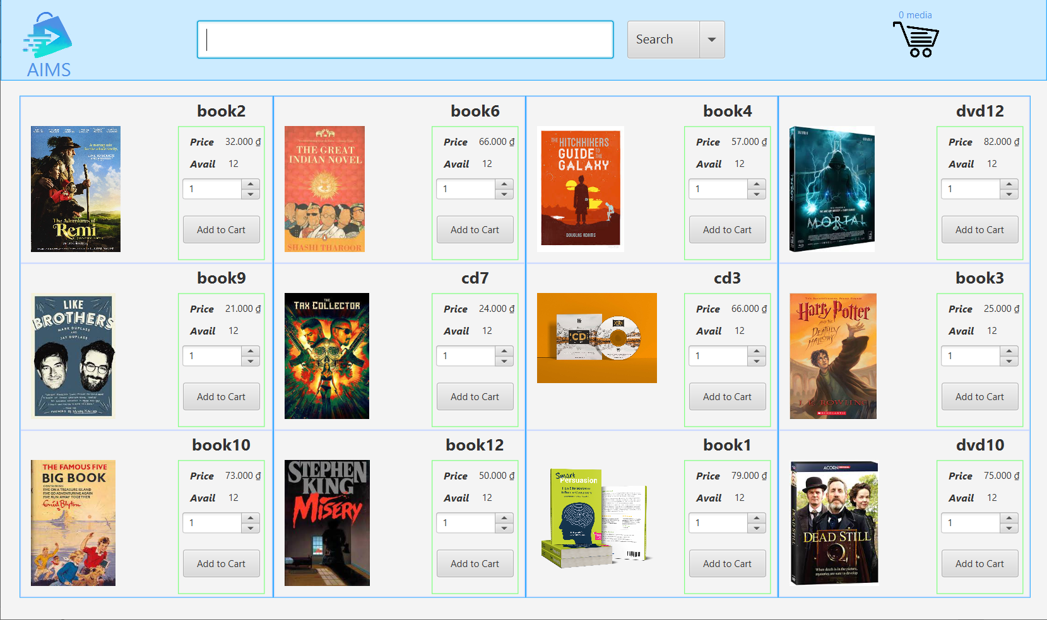

***View cart screen***

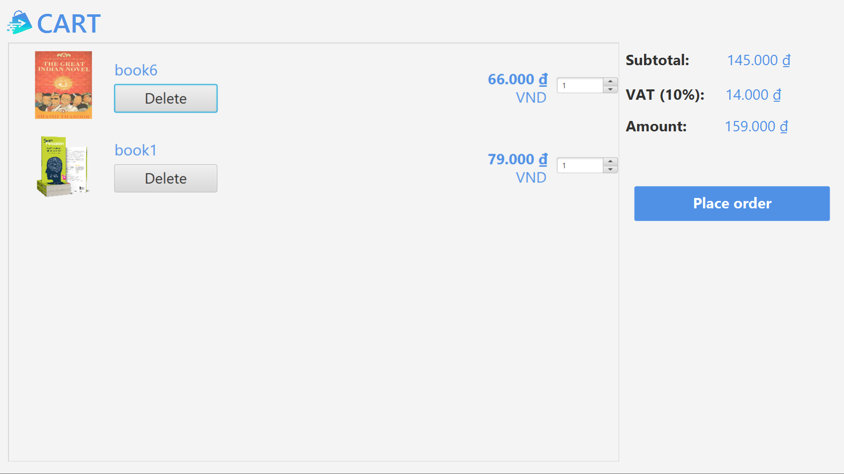

***Delivery info screen***

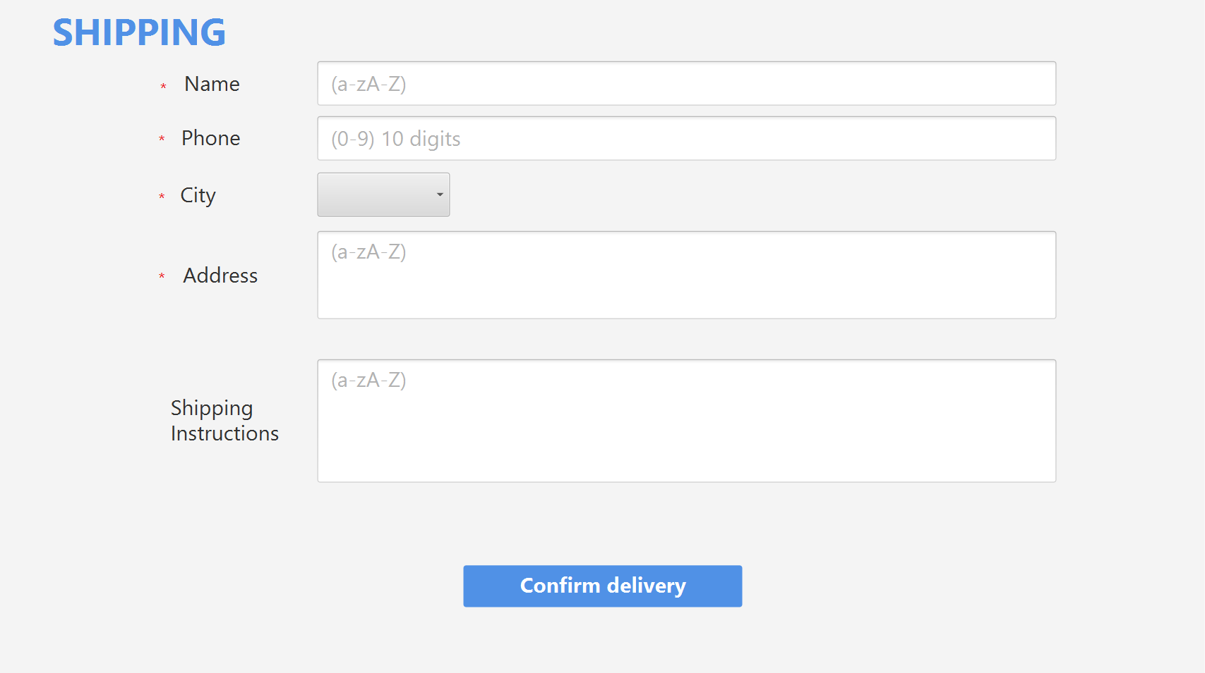

***Delivery method screen***

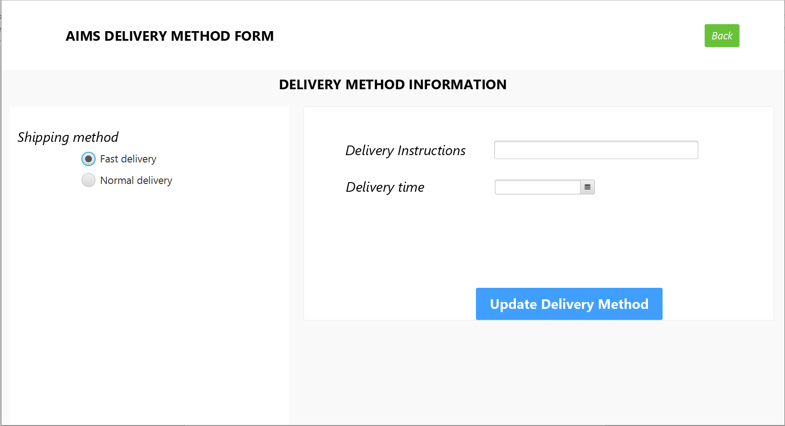

***Invoice screen***

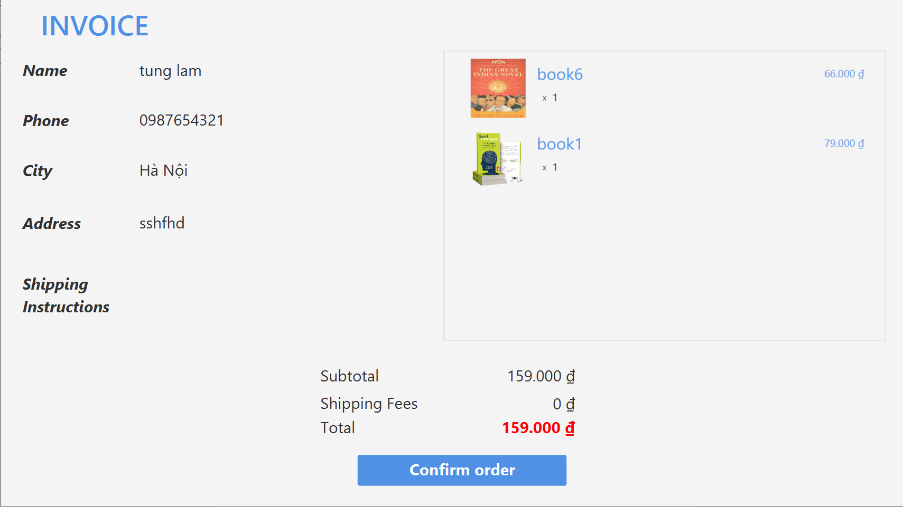

***Payment screen with VNPay***

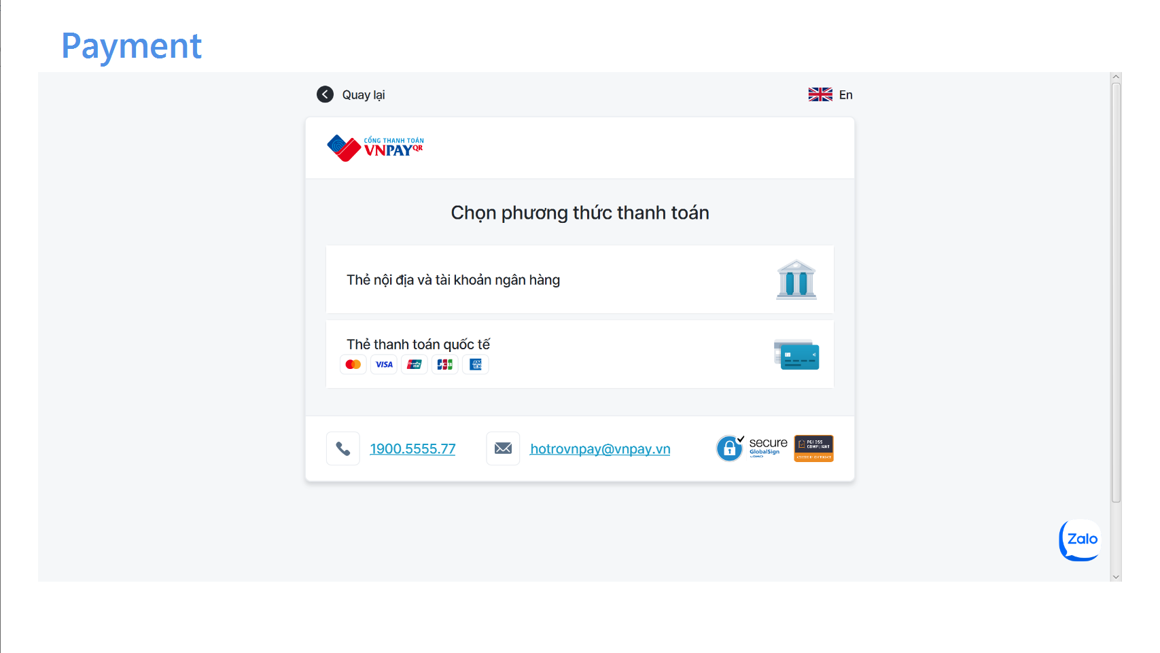

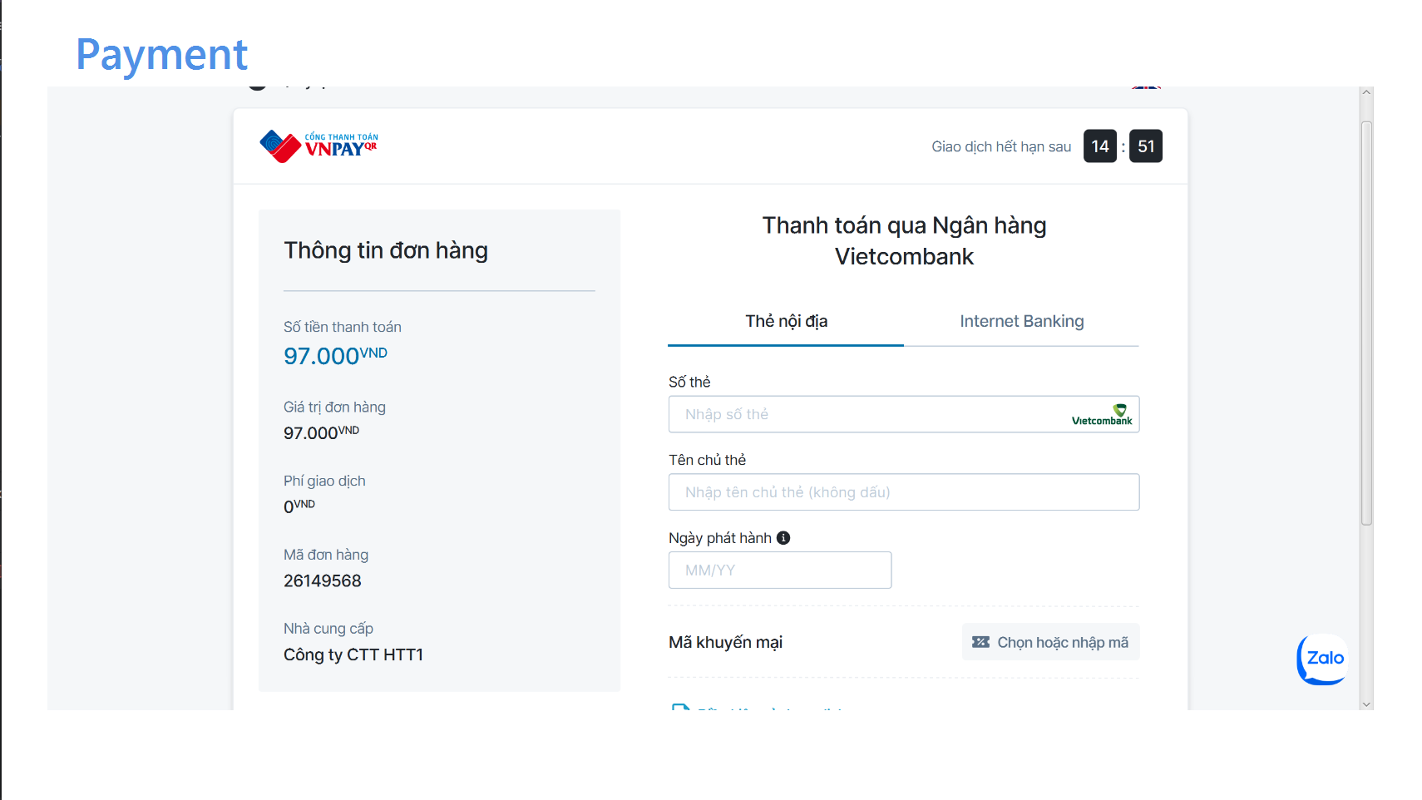

***Result screen***

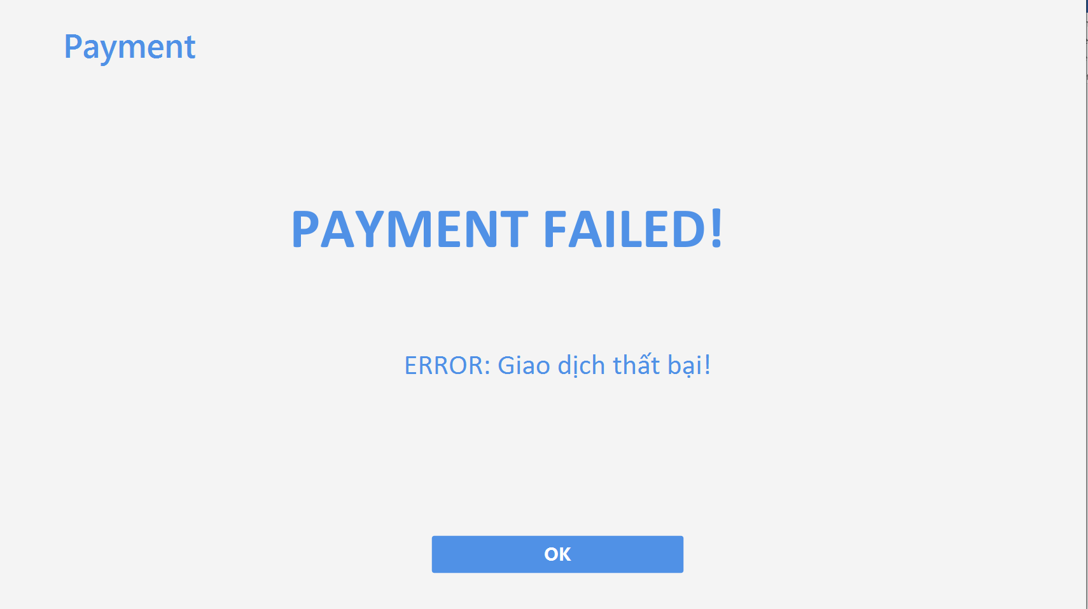

**3. Creating a screen transition diagram**

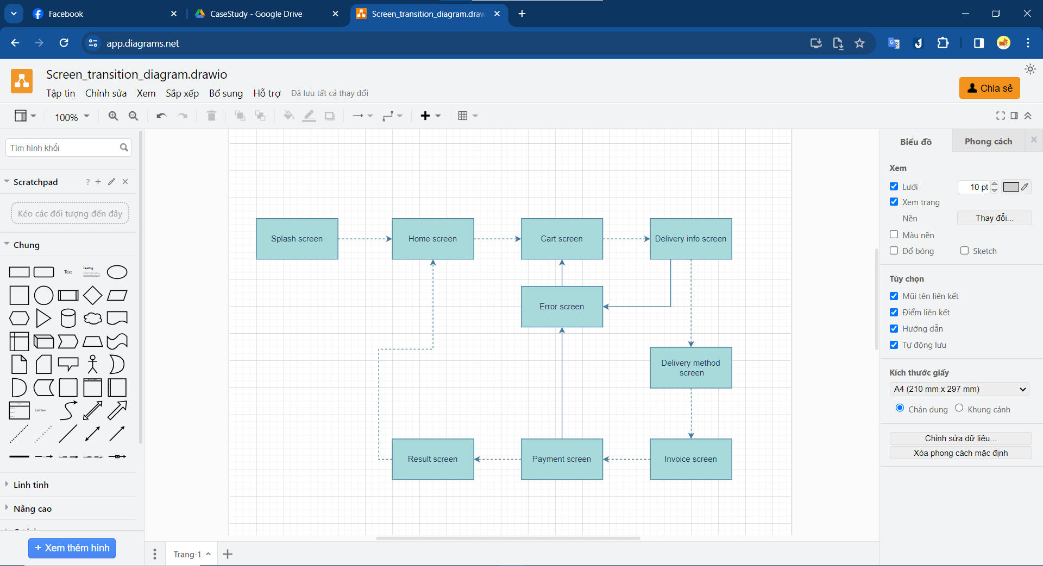

**4. Creating screen specification**

***Splash screen***

|  |  |  |  |  |  |
| --- | --- | --- | --- | --- | --- |
| AIMS Software | | Date of creation | Approved by | Reviewed by | Persion in charge |
| Screen specification | Splash screen | 22/11/2023 |  |  | Đinh Duy Anh |
|  |  | Control | Operation | Function |  |
|  | | Area for displaying the logo of AIMS | Initial | Display the logo of the AIMS software | |

***Home screen***

|  |  |  |  |  |  |
| --- | --- | --- | --- | --- | --- |
| AIMS Software | | Date of creation | Approved by | Reviewed by | Persion in charge |
| Screen specification | Home screen | 22/11/2023 |  |  | Đinh Duy Anh |
|  |  | Control | Operation | Function |  |
|  | | Area for displaying the header | Initial | Display the logo of the AIMS software, search field, button field and the cart with number of items in the cart | |
|  | | Area for displaying list items | Initital | Display items randomly | |
|  | | Search button | Click | Display list of items base on the keyword search | |
|  | | Cart icon | Click | Display cart screen | |
|  | | Plus/Minus button | Click | Increase or decrease the number of items customer want to add to the cart | |
|  | | AddtoCart button | Click | Add items and corresponding quantities to the cart | |

|  |  |  |  |  |
| --- | --- | --- | --- | --- |
| Screen name | Home screen |  |  |  |
| Item name | Number of  digits (bytes) | Type | Field attribute | Remarks |
| Keyword Search | 50 | Numeral | Black | Left-justified |
| Media title | 50 | Numeral | Black | Center-justified |
| Price | 20 | Numeral | Black | Left-justified |
| Available quantity | 20 | Number | Black | Right-justified |
| Quantity | 10 | Number | Black | Center-justified |

***Cart screen***

|  |  |  |  |  |  |
| --- | --- | --- | --- | --- | --- |
| AIMS Software | | Date of creation | Approved by | Reviewed by | Persion in charge |
| Screen specification | Cart screen | 22/11/2023 |  |  | Đinh Duy Anh |
|  |  | Control | Operation | Function |  |
|  | | Area for displaying items in the cart | Initial | Display the media with the corresponding information | |
|  | | Area for displaying the subtotal | Initital | Display the subtotal | |
|  | | Up/Down arrow button | Click | Increase or decrease the number of item in the cart | |
|  | | Delete button | Click | Remove the item from the cart | |
|  | | Place order button | Click | Display the shipping screen (Delivery form) | |
|  | | Back button | Click | Display home screen | |

|  |  |  |  |  |
| --- | --- | --- | --- | --- |
| Screen name | Cart screen |  |  |  |
| Item name | Number of  digits (bytes) | Type | Field attribute | Remarks |
| Media title | 50 | Numeral | Black | Center-justified |
| Price | 20 | Numeral | Black | Center-justified |
| Quantity | 10 | Number | Black | Center-justified |
| Subtotal | 20 | Numeral | Black | Right-justified |
| Amount | 20 | Numeral | Black | Right-justified |

***Delivery info screen***

|  |  |  |  |  |  |
| --- | --- | --- | --- | --- | --- |
| AIMS Software | | Date of creation | Approved by | Reviewed by | Persion in charge |
| Screen specification | Delivery info screen | 22/11/2023 |  |  | Đinh Duy Anh |
|  |  | Control | Operation | Function |  |
|  | | Area for displaying delivery information fields | Initital | Display the delivery form | |
|  | | Back button | Click | Display to delivery info screen | |
|  | | Confirm delivery button | Click | Display the delivery method screen | |

|  |  |  |  |  |
| --- | --- | --- | --- | --- |
| Screen name | Delivery form |  |  |  |
| Item name | Number of  digits (bytes) | Type | Field attribute | Remarks |
| Name | 50 | Letters | Black | Left-justified |
| Phone | 20 | Number | Black | Left-justified |
| City | 30 | Letters | Black | Left-justified |
| Address | 100 | Numeral | Black | Left-justified |
| Shipping instructions | 100 | Numeral | Black | Left-justified |

***Delivery Method Screen***

|  |  |  |  |  |  |
| --- | --- | --- | --- | --- | --- |
| AIMS Software | | Date of creation | Approved by | Reviewed by | Persion in charge |
| Screen specification | Delivery method screen | 22/11/2023 |  |  | Đinh Duy Anh |
|  |  | Control | Operation | Function |  |
|  | | Area for displaying fast delivery information fields | Initital | Display the fast delivery form. If user select “Normal delivery” or select “Fast Delivery” but no products support/city is not Hà Nội, the form will be disabled | |
|  | | Back button | Click | Display delivery info screen | |
|  | | Update Delivery Method button | Click | Display the invoice screen | |
|  | | Calendar icon | Click | Display date picker | |

***Invoice screen***

|  |  |  |  |  |  |
| --- | --- | --- | --- | --- | --- |
| AIMS Software | | Date of creation | Approved by | Reviewed by | Persion in charge |
| Screen specification | Invoice screen | 22/11/2023 |  |  | Đinh Duy Anh |
|  |  | Control | Operation | Function |  |
|  | | Area for displaying items in the cart | Initial | Display the media in the cart with the corresponding information | |
|  | | Area for displaying delivery information | Initital | Display delivery info | |
|  | | Area for displaying toal & fee information | Initial | Display subtotal, shipping fees and total money information | |
|  | | Confirm order button | Click | Display the payment screen | |

|  |  |  |  |  |
| --- | --- | --- | --- | --- |
| Screen name | Invoice screen |  |  |  |
| Item name | Number of  digits (bytes) | Type | Field attribute | Remarks |
| Media title | 50 | Numeral | Black | Center-justified |
| Price | 20 | Numeral | Black | Center-justified |
| Quantity | 10 | Number | Black | Center-justified |
| Name | 50 | Letters | Black | Left-justified |
| Phone | 20 | Number | Black | Left-justified |
| City | 30 | Letters | Black | Left-justified |
| Address | 100 | Numeral | Black | Left-justified |
| Shipping instructions | 100 | Numeral | Black | Left-justified |
| Subtotal | 20 | Numeral | Black | Right-justified |
| Shipping fees | 20 | Numeral | Black | Right-justified |
| Total | 20 | Numeral | Red | Right-justified |

***Payment screen***

|  |  |  |  |  |  |
| --- | --- | --- | --- | --- | --- |
| AIMS Software | | Date of creation | Approved by | Reviewed by | Persion in charge |
| Screen specification | Payment screen | 22/11/2023 |  |  | Đinh Duy Anh |
|  |  | Control | Operation | Function |  |
|  | | Area for displaying payment method | Initial | Displays payment method options | |
|  | | Area for displaying payment information  fields | Initital | Display the payment form | |
|  | | Back button | Click | Display to invoice screen | |
|  | | Confirm payment button | Click | Transaction processing and display result screen | |
|  | | Cancel Payment Button | Click | Cancel payment and display payment failed screen | |

|  |  |  |  |  |
| --- | --- | --- | --- | --- |
| Screen name | Payment screen |  |  |  |
| Item name | Number of  digits (bytes) | Type | Field attribute | Remarks |
| Card number | 30 | Numeral | Black | Left-justified |
| Card holder name | 50 | Numeral | Black | Left-justified |
| Expiration date | 10 | Date | Black | Left-justified |
| Card security code | 3 | Number | Black | Left-justified |
| OTP Password | 6 | Number | Black | Left-justified |

***Payment result screen***

|  |  |  |  |  |  |
| --- | --- | --- | --- | --- | --- |
| AIMS Software | | Date of creation | Approved by | Reviewed by | Persion in charge |
| Screen specification | Payment result screen | 22/11/2023 |  |  | Đinh Duy Anh |
|  |  | Control | Operation | Function |  |
|  | | Area for displaying transaction result | Initial | Displays transaction result | |
|  | | OK button | Click | Back to home screen | |